# Lexical resource

* **splurge (sth, money) on sth N/v  [splɜːdʒ]  = squander money,** to spend more money than you can usually afford 乱花钱，挥霍 [SYN](javascript:;) SPLASH OUT 【非正式】   
  e.g. Within a couple of months, I’d splurged about £2,500 on clothes. 就在几个月时间里，我买衣服花掉了 2,500 英镑。
* **[ control the purse strings: 控制财权; 控制财政大权；]**e.g. In your household, who **controls the purse strings**, you or your wife?
* **[ N] a coin toss = flip the coin into the air and guess “heads or tails”? 抛硬币猜正反面]**

e.g. He determined who will go first—Obama—with a coin toss.  他抛了一次硬币——用来决定先见哪个——结果是奥巴马。  
e.g. The formal name was determined by the gracious winner of a coin toss.  正式名称视 **抛硬币猜正反面** 幸运获胜者而定。

* in my infancy 在开始阶段e.g. Some forms of robotics are still in our infancy. But we’ll develop them and roll out them asap
* bandwagon

1. an activity that a lot of people are doing 风行的活动，风尚，浪潮 e.g. The keep-fit bandwagon started rolling in the mid-80s. 八十年代中期，健身热潮开始涌现。=> figurative meaning: 见风使舵;
2. **climb/jump/get on the bandwagon**: to start doing or saying something that a lot of people are already doing or saying – used to show disapproval 赶浪头赶时髦，顺应潮流; 随波逐流〔含贬义〕 [Bandwagon Appeal 利用从众心理; 随波逐流]  
   e.g. I don’t want to look as if I’m jumping on a green bandwagon. 我不想显得我是在随大溜参与环保。
3. Bandwagon  乐队花车 V.S. floats花车
4. **bandwagon fans****伪粉丝**

* 一点都不像啊，没有可比性啊  
  [ there is no comparison between A and B.

Comparing A and B is just like comparing an apple and an orange. /chalk and cheese.

A **bear no resemblance to** B. 一点都不像啊，没有可比性啊

A is really removed far way from B ]

* [ fur coat] 皮毛大衣；皮草大衣, which is not standing in side with “Against Cruelty to Animals”  
  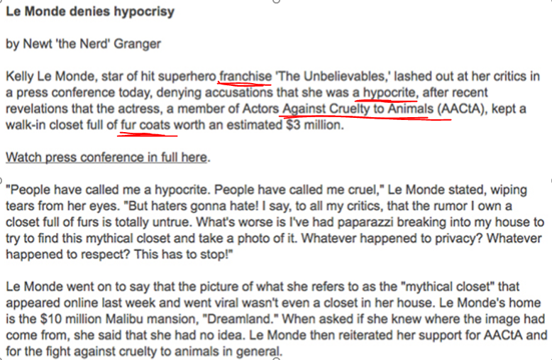
* AACtA: Actors Against Cruelty to Animals.

e.g.

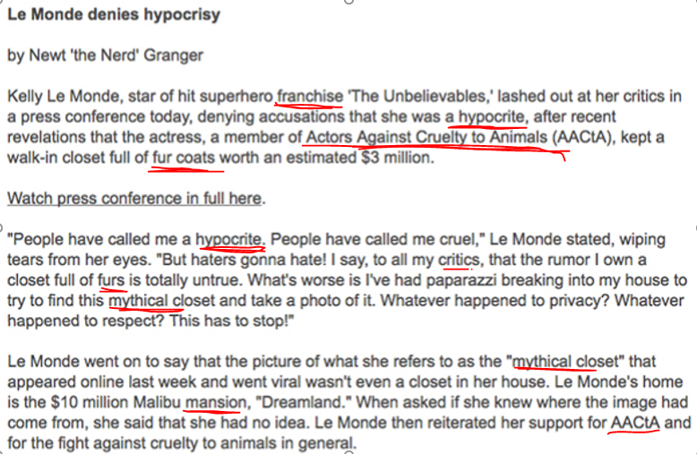

* pious  /'paɪəs,ˋpaɪəs/ adj. DERIVATIVE 派生词 piously adv
* having strong religious beliefs, and showing this in the way you behave〔对宗教〕虔诚 e.g. He was a quiet, pious man. 他是个文静、虔诚的人。
* if you describe what someone says as **pious talk, pious words, pious speech** etc, you mean that they are trying to sound good, ethical, or moral but you do not believe that they are sincere or will really do what they say 假虔诚的，虚伪的，伪善的 **[虚伪演讲pious speech; pious talk; pious words] V.S. [ a hypocritical person ]** e.g. pious speeches by politicians about ‘family values’ 政客们关于所谓“家庭价值观”的虚伪演讲
* **[ pious hope; pious wish]** is something that you want to be true or to happen, but that is very unlikely 不大可能实现的希望/愿望 e.g. All these agreements and ideas remain little more than **pious hopes** in the present climate. 所有这些协议和想法在目前的环境下都是 **不可能实现的愿望。**
* hypocritical [‚h**ɪp**ə'krɪtɪk ə ]; hypocritically; **hypocrisy  N) [hɪ'pɑkrəsi]**

behaving in a way that is different from what you claim to believe – used to show disapproval

伪善的，虚伪的，假惺惺的〔含贬义〕**it’s hypocritical (of sb) to do sth**

e.g. It’s hypocritical of these universities to call their football players student-athletes. 这些大学称自己的橄榄球队员是学生运动员，真虚伪。

e.g**. It’s hypocritical of sb. to** call all z IDs “the best ID in the world”

V.S. **[虚伪演讲pious /'paɪəs/ speech; pious talk; pious words] V.S. [ a hypocritical person ]**

* hypocrisy  N) [hɪ'pɑkrəsi] 虚伪(之举)；伪善(之举);  hypocrisies: when someone pretends to have certain beliefs or opinions that they do not really have – used to show disapproval伪善，虚伪〔含贬义〕 e.g. It would be sheer hypocrisy[hɪ'pɑkrəsi]虚伪之举 to pray for success, since I’ve never believed in God. 我从不相信上帝，因此为获成功而祈祷是纯粹的虚伪之举。
* incriminate /ɪnˈkrɪmɪˌneɪt/  |TEM8 (incriminatingincriminatedincriminates)

1. [V-T](javascript:;)[ incriminate sb.] If something incriminates you, it suggests that you are responsible for something bad, especially a crime. 显示…有罪 e.g. He claimed that the drugs had been planted to incriminate him, in other words, he was framed/set up（被陷害了）  他声称那些毒品是有人为了栽赃陷害他而放在那里的。
2. [ADJ](javascript:;)显示有罪的 [ 罪证incriminating evidence] e.g. Police had reportedly searched his house and found incriminating evidence. 并且发现了罪证。

* With every fiber of my being = I firmly believe xxx
* pointless: worthless, meaningless, or not likely to have any useful result 无益的，无用的 e.g. Life just seemed pointless to me. 生活对我来说简直 没什么意义/没有用。

E.g. a pointless quarrel 无谓的争吵

**[ It is pointless doing sth ] 做<xxx事情>是没有用的/徒劳的白搭**

e.g. **It’s pointless telling** her to clean her room – she’ll never do it. 叫她打扫自己的房间 **没有用的/徒劳的白搭**，她绝对不会去干的。

e.g. In DP team, **it’s pointless assigning tasks** to Travis – he’ll never do it by himself or even will never to do.

**[ it is pointless to do sth] 做xxx事情毫无意义 = [ there is no point to do sth ] = it’s worthless and meaningless to do sth**e.g. I think it would be pointless to discuss this issue again. 我认为再讨论这个问题 毫无意义

* “nest egg” an amount of money that you have saved so that you can use it for something special in the future 个人储蓄金，储备金 e.g. They had to use part of their retirement nest egg to pay for their son’s college fees. 他们得动用部分退休金来支付儿子念大学的费用。
* [kleft]  cleft 1. a natural crack in something, especially the surface of rocks or the Earth 〔地球或岩石表面的〕裂缝，裂口 2. an area on the chin or lip that goes slightly inwards〔下巴或嘴唇上的〕凹痕，凹口; 兔唇
* zombie /ˈzɒmbɪ/

1. (literal meaning) In horror stories and some religions, a zombie is a dead person who has been brought back to life. 僵尸; 行尸走肉 V.S. vampire ['væmpaɪə] n. 吸血鬼
2. [(figurative meaning)](javascript:;)You can describe someone as a zombie if their face or behaviour shows no feeling, understanding, or interest in what is going on around them. 麻木迟钝/麻木不仁的人; 无精打采的人 e.g.  Without sleep you will become a zombie at work.   如果不睡觉，工作时会变得无精打采的。
3. informal someone who moves very slowly and does not seem to be thinking about what they are doing, especially because they are very tired 〔尤指因极度疲劳而〕行动迟缓的人，无精打采的人 e.g. I walked around l ike a zombie for most of the day. 我一天大部分时间里走到哪儿都(像个僵尸/行尸走肉一样)无精打采
4. a computer that someone has secretly gained control of and uses to do things such as send spam(= unwanted emails sent to a large number of people ) 僵尸（计算机）〔被某人暗中控制用来滥发垃圾邮件等的计算机〕

# Phrases

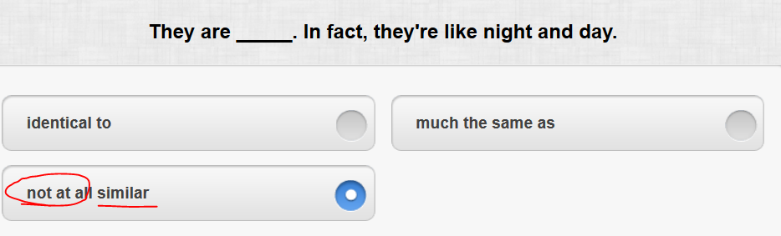

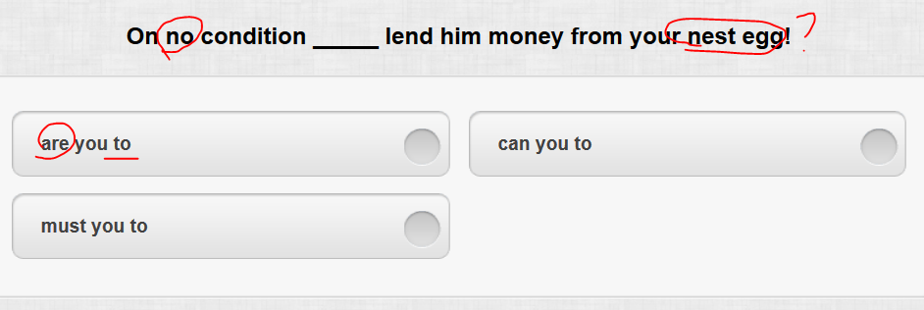

倒装

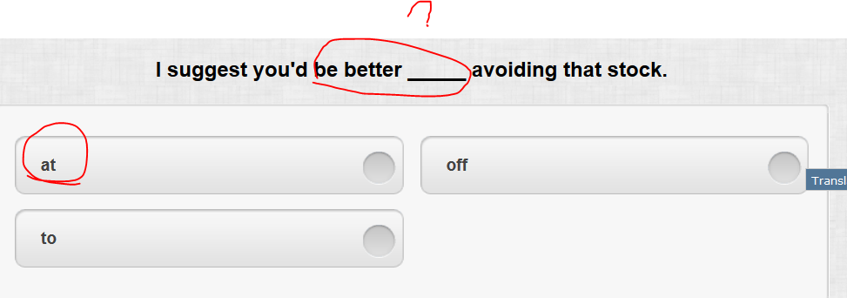

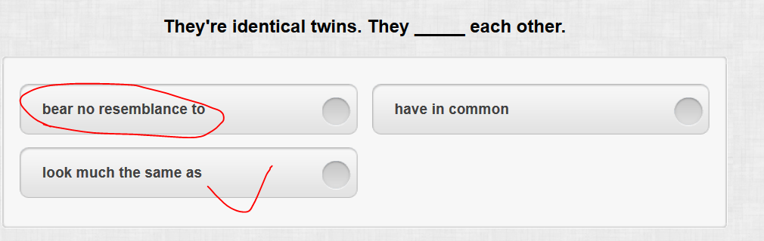

[ there is no comparison between A and B.

Comparing A and B is just like comparing an apple and an orange. /chalk and cheese.

A bear no resemblance to B.

A is really removed far way from B ]

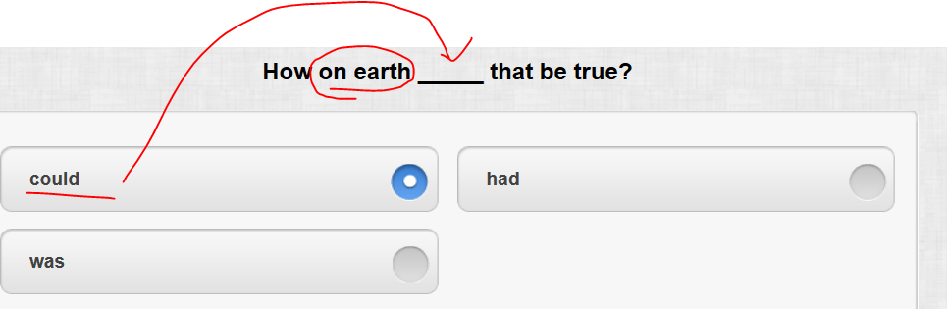

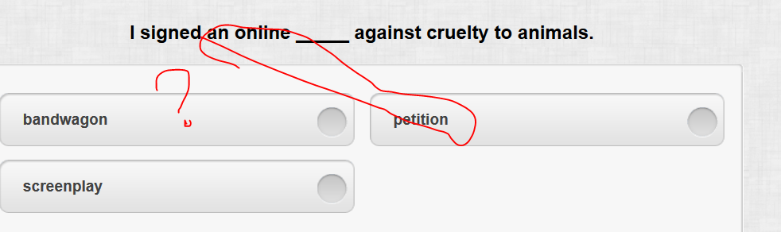

Bandwagon

1. an activity that a lot of people are doing 风行的活动，风尚，浪潮 e.g. The keep-fit bandwagon started rolling in the mid-80s. 八十年代中期，健身热潮开始涌现。=> figurative meaning: 见风使舵;
2. climb/jump/get on the bandwagon: to start doing or saying something that a lot of people are already doing or saying – used to show disapproval 赶浪头赶时髦，顺应潮流; 随波逐流〔含贬义〕 [. Bandwagon Appeal 利用从众心理; 随波逐流]  
   e.g. I don’t want to look as if I’m jumping on a green bandwagon. 我不想显得我是在随大溜参与环保。
3. Bandwagon  乐队花车 V.S. floats花车
4. bandwagon fans 伪粉丝

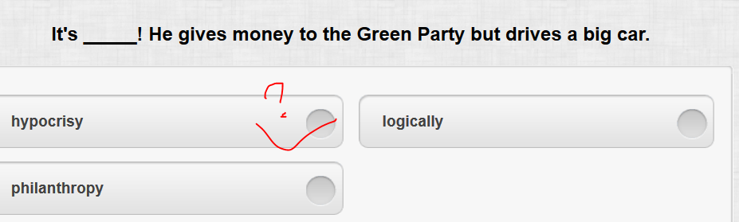

//hypocrisy=>hypocritical

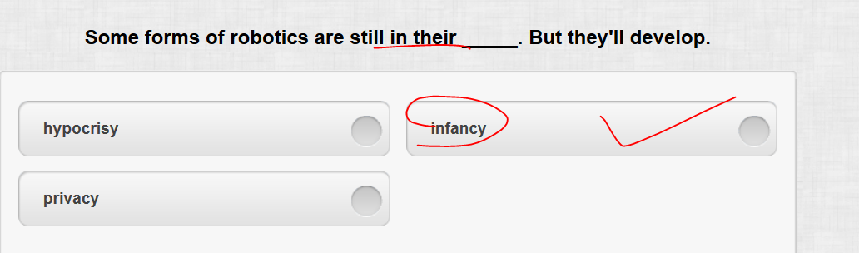

// in my infancy 在开始阶段

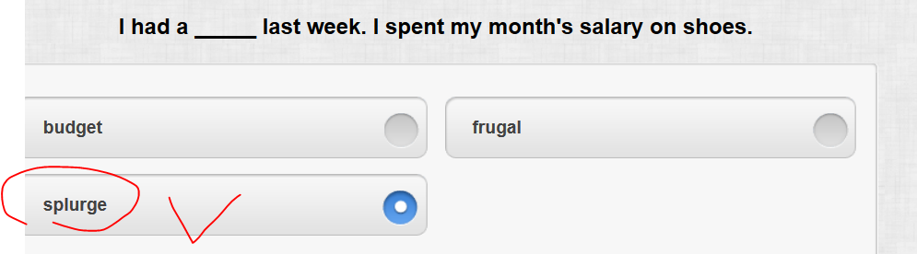

// splurge (sth) on sth N/v  [splɜːdʒ]  = squander money, to spend more money than you can usually afford 乱花钱，挥霍 [SYN](javascript:;) SPLASH OUT 【非正式】 e.g. Within a couple of months, I’d splurged about £2,500 on clothes. 就在几个月时间里，我买衣服花掉了 2,500 英镑。

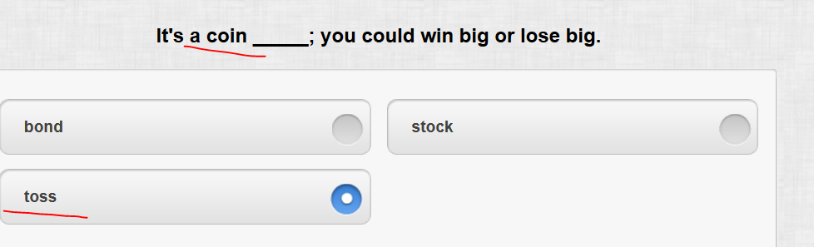

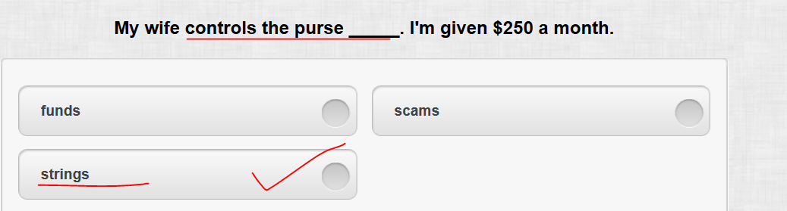

**[ control the purse strings: 控制财权; 控制财政大权；]**

# Reading: augmented reality

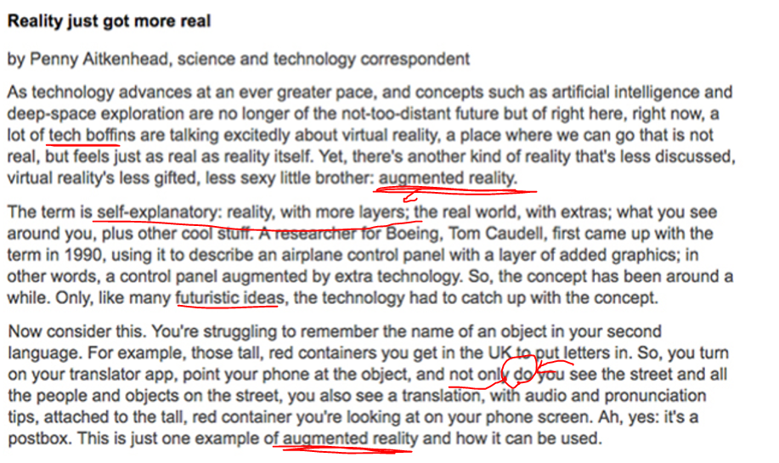

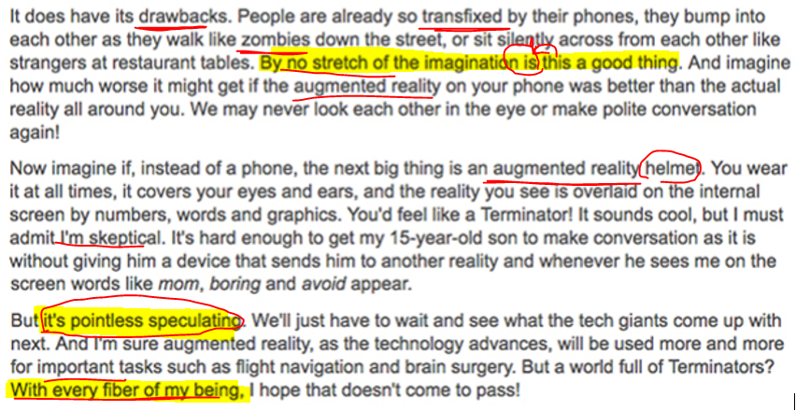

//With every fiber of my being = I firmly believe xxx

# Reading: Actor Against Cruelty to Animals (AACtA)



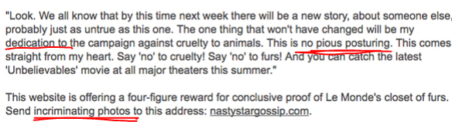

* Pious  /'paɪəs,ˋpaɪəs/ adj. DERIVATIVE 派生词 piously adv
* having strong religious beliefs, and showing this in the way you behave〔对宗教〕虔诚 e.g. He was a quiet, pious man. 他是个文静、虔诚的人。
* if you describe what someone says as **pious talk, pious words, pious speech** etc, you mean that they are trying to sound good, ethical, or moral but you do not believe that they are sincere or will really do what they say 假虔诚的，虚伪的，伪善的 **[虚伪演讲pious speech]** e.g. pious speeches by politicians about ‘family values’ 政客们关于所谓“家庭价值观”的虚伪演讲
* **[ pious hope; pious wish]** is something that you want to be true or to happen, but that is very unlikely 不大可能实现的希望/愿望 e.g. All these agreements and ideas remain little more than **pious hopes** in the present climate. 所有这些协议和想法在目前的环境下都是 **不可能实现的愿望。**
* incriminate /ɪnˈkrɪmɪˌneɪt/  |TEM8 (incriminatingincriminatedincriminates)

1. [V-T](javascript:;)[ incriminate sb.] If something incriminates you, it suggests that you are responsible for something bad, especially a crime. 显示…有罪 e.g. He claimed that the drugs had been planted to incriminate him, in other words, he was framed/set up（被陷害了）  他声称那些毒品是有人为了栽赃陷害他而放在那里的。
2. [ADJ](javascript:;)显示有罪的 [ 罪证incriminating evidence] e.g. Police had reportedly searched his house and found incriminating evidence. 并且发现了罪证。